

Report of Software Architecture

Homework 3.2-1: Factory Method Pattern

Basic information
Team name： RADAR_________________________
Class number:_______________20软嵌1____________________________
Department/school： 徐州工程学院
Team members with student numbers：
蔡超萍：20200507105
吴巧妍：20200507101

Instructor’s comments and score
comments：

score：
signature of the instructor：

Year month date
作业要求：Understand the following class diagram. All the source code using object adapter pattern in Java has been given to you except for the code for class ChinesePostalCode and ChinesePostalCodeAdapter.
ZipCodeTester
isValidZipCode(zip:String):
boolean
USAZipCode
isValidCanadianPCode
(pcode: String): boolean
CanadianPostalCode
CAPostalCodeAdapter
isValidZipCode(zip:String):
boolean
isValidZipCode(zip:String):
boolean
<<interface>>
ZipCodeValidater
Customer
isValidChinesePCode
(pcode: String): boolean
ChinesePostalCode
ChinesePostalCodeAdapter
isValidZipCode(zip:String): boolean

Now
- Write code for class ChinesePostalCode, in which writing code for the method isValidChinesePCode(pcode: String). The correct format of Chinese postal code has a format like 150001, that is, 6 digit numbers.
- Then you write code for the class ChinesePostalCodeAdapter.
- Add some code in class ZipCodeTester to make the program works for all the US zipcode, Canadian postal code and Chinese postal code, if needed.

1． 学生对自己已经完成的作业的描述（你具体怎样完成了作业？例如，在原来的类图中，你新增加了哪些类？新增加的类与原来的类之间有什么样的关系？你在哪个类中增添了什么代码？这些新添加的类与原来的类有什么关系？等等）
蔡超萍：
我在原来的类图中增加了ChinesePostalCode，该类实现了ZipCodeValidator接口，实现了抽象方法isValidZipCode，完成了对邮编合法性的检验，与CanadianPostalCode实现的功能相似。
吴巧妍：
在类图中增加了ChinesePostalCodeAdapter类，新增的类是上述ChinesePostalCode的适配器，实现了ZipCodeValidator接口，与原先的CAPostalCodeAdapter，是一种类型。并且负责类图的绘制。
蔡超萍：
此外，在ZipCodeTester中完善了China邮编相关的情况。在Customer中完善了对于中国邮编的适配，代码如下：
if (country.equals(Customer.CHINA)){
ChinesePostalCode objCAPCode = new ChinesePostalCode();
ZipCodeValidator adapter = new ChinesePostalCodeAdapter(objCAPCode);
return adapter.isValidZipCode(zip, state);
}
return false;

2． 类关系图（你所设计的类关系图）
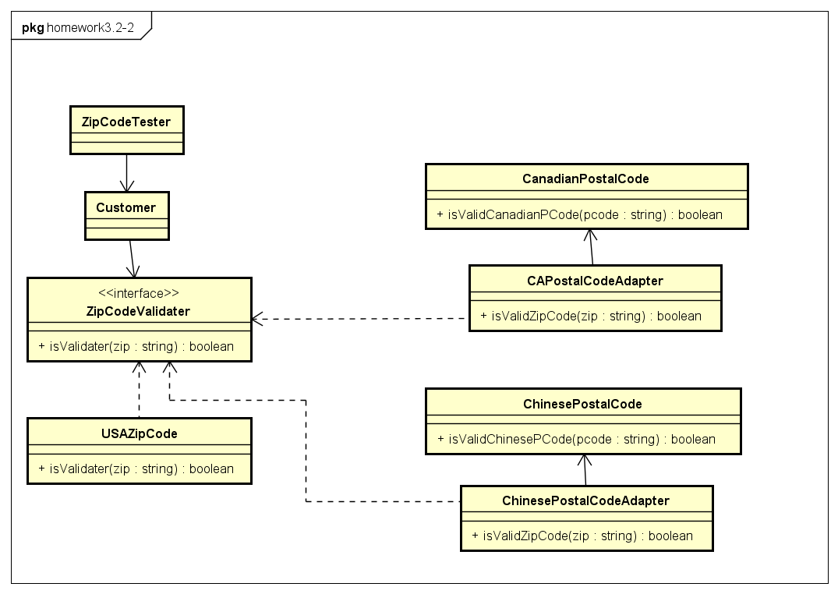

3． 关键代码，关键参数的传递 （指出你的实现所规定的功能时所用的关键代码）
功能编码如下：
package Code;
/**
* @author gra1n
* @Classname:ChinesePostalCode
* @DateTime:2022/10/15 20:02
**/
public class ChinesePostalCode implements ZipCodeValidator {
private boolean digitFlag = true;
private String zip;
private final int ZIPLEN =6;
public boolean isValidZipCode(String zip,String state) {
char[] zp = toNonBlankCharArray(zip);
for(int i=0; i< ZIPLEN; i++){
if( Character.isDigit(zp[i]) == false) {
digitFlag = false;
}
}
return digitFlag;
}
public char[] toNonBlankCharArray(String postalCode){
int m=0;
for (int k=0;k<postalCode.length(); k++){
if (Character.isSpaceChar(postalCode.charAt(k)) == false ){
m++;
}
}
char[] p = new char[m];
int n = 0;
for (int k=0;k<postalCode.length(); k++){
if (Character.isSpaceChar(postalCode.charAt(k)) == false ){
p[n] = postalCode.charAt(k);
n++;
}
}
return p;
}
// public static void main(String[] args){
// ChinesePostalCode c=new ChinesePostalCode();
// boolean d= c.isValidZipCode("123456","jiangsu");
// System.out.println(d);
// }
}
适配器代码如下
package Code;
/**
* @author gra1n
* @Classname:ChinesePostalCodeAdapter
* @DateTime:2022/10/15 20:02
**/
public class ChinesePostalCodeAdapter extends ChinesePostalCode implements ZipCodeValidator{
private ChinesePostalCode objCPostCode;
public ChinesePostalCodeAdapter(ChinesePostalCode pCode) {
objCPostCode = pCode;
}
}

4． 其它说明
适配器模式将目标类和适配者类解耦增加了类的透明性和复用性，将具体的实现封装在适配者类中，对于客户端类来说是透明的，而且提高了适配者的复用性，灵活性和扩展性都非常好，符合开闭原则。由于适配器类是适配者类的子类，因此可以再适配器类中置换一些适配者的方法，使得适配器的灵活性更强。

5． 典型输入与输出
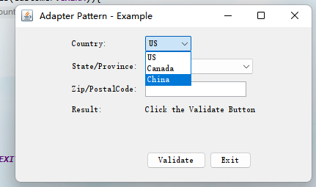

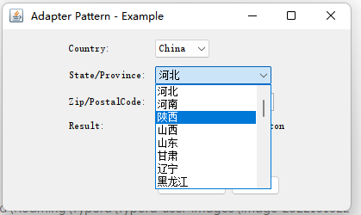

错误样例：
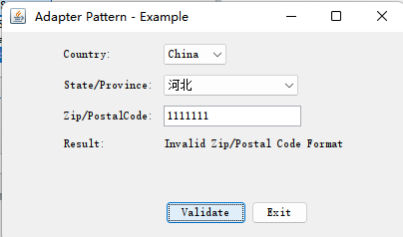

正确样例：
